# Contents

Contents 1

Introduction 2

مقدمه 3

Setting Up Your Headset 4

Minimum System Requirements for PC/Mac 4

Battery 4

Power 4

LED Light 4

Fitting the MindWave 5

The MindWave Reader 6

eSense Meter 7

ATTENTION eSense 7

MEDITATION eSense 7

GitHub 9

# Introduction

MindWave Reader or WebDesignIran NeuroSky MindWave Reader is an open source and windows platform based software application that connect to NeuroSky MindWave and MindWave Mobile EEG headsets. This application helps to monitor captured brain waves. MindWave Reader is useful software for any user specially for software developers or researchers.

This Brain-Computer Interface (BCI) device turns your brainwaves into actions, unlocking new worlds of interactivity. The MindWave reports the wearer’s mental state in the form of NeuroSky's proprietary Attention and Meditation eSense™ algorithms, along with raw wave and information about the brainwave frequency bands. The NeuroSky MindWave can be used with supported video games, research software, or a number of other applications for an enhanced user experience.

# مقدمه

سامانه نرم افزاری MindWave Reader یا به عبارت کامل تر WebDesignIran NeuroSky MindWave Reader یک نرم افزار منبع باز مبتنی بر سیستم عامل مایکروسافت است که با اتصال به هدست MindWave and MindWave Mobile می تواند اطلاعات امواج مغزی را ضبط شده را نمایش دهد. این نرم افزار برای برنامه نویسان و محققان می تواند مناسب باشد.

# Setting Up Your Headset

## Minimum System Requirements for PC/Mac

We developed MindWave Reader on Windows 10 but you can used on any Microsoft Windows Platform that supported .Net Framework Version 4.5 and higher. Also MindWave have some PC (Windows) requirements like:

**Operating System:** Minimum Microsoft Windows 7 (with Service Pack 1/SP1)

**Processor:** Intel Core Duo or equivalent

**Memory:** 1GB or more

**Video:** DirectX 9.0 or greater

## Battery

The MindWave RF and MindWave Mobile headsets require 1 AAA battery to operate, which provides 8 hours of run time. To install or replace the battery, slide open the battery cover. Remove any existing battery within and replace with a new AAA battery, making sure the polarity +/- are aligned correctly.

We recommend use of AAA rechargeable battery for long use and we recommended stop and start (or close and start again) software after change battery.

## Power

To power on the MindWave Mobile headsets, slide the switch to the ON (middle) position. When held past the ON position for 3 seconds and then released, the headset will enter Bluetooth pairing mode. I’d the switch is held past the ON position for 6 seconds, the headset's pairing memory will be cleared. To turn the MindWave Mobile off, slide the switch back to the OFF position.

## LED Light

The MindWave's LED light has two colors: red and blue. Refer to the chart to see what state the MindWave is in.

|  |  |  |
| --- | --- | --- |
| Light Color | Blinking | MindWave Stats |
| Off |  | Powered off. |
| Red | No | Powered on but not connected |
| Blue | No | Powered on and connected |
| Red or Blue | Yes | Low battery |

## Fitting the MindWave

The MindWave is more than your average headset. It has the ability to use your brainwaves for exciting new applications. In order to take full advantage of these functions and features of the MindWave, the MindWave must be properly worn.

1. Orient the MindWave with the forehead Sensor Arm on your left hand side. Rotate the Sensor Arm from its base by about 90 degrees. It can be rotated slightly more if necessary to get proper fit and comfort.
2. The overhead band of the MindWave is adjustable and can be extended to fit various sizes. Put on the MindWave. If the sensor does not make contact with the forehead or if the fit is not comfortable, remove the MindWave to readjust the overhead band and the forehead Sensor Arm. The forehead Sensor Arm is flexible and should arch inwards.
3. Allow the rubber ear hoop to rest behind your left ear, and then clip the earclip onto your earlobe.
4. Make sure the two metal contacts on the inside of both sides of the earclip make skincontact with your earlobe or ear. Move any hair or obstructions (such as jewelry) out of the way. Readjust the earclip as necessary to make proper contact with the skin of your ear. You may need to squeeze the ear clip against your ear for a few moments.
5. Adjust the forehead Sensor Arm of the headset so that the Sensor Tip makes contact with the skin of your forehead. This Sensor Tip must maintain steady skin contact in order to properly measure your brainwaves. The Sensor Tip should be comfortable, yet stay firmly in position. Keep hair away from the sensor – the sensor must be able to directly contact the skin at all times. Make up, dead skin, or debris can interfere with the connection. Scratch or wipe the obstruction away if you have trouble obtaining a clean signal.

# The MindWave Reader

The last century of neuroscience research has greatly increased our knowledge about the brain and particularly, the electrical signals emitted by neurons firing in the brain. The patterns and frequencies of these electrical signals can be measured by placing a sensor on the scalp. The MindTools line of headset products contain NeuroSky ThinkGear™ technology, which measures the analog electrical signals, commonly referred to as brainwaves, and processes them into digital signals.

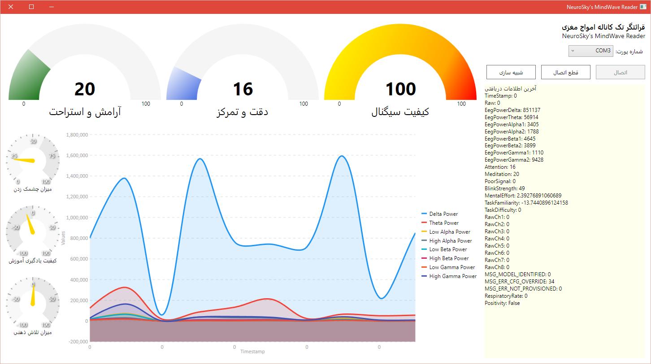

The ThinkGear technology then makes those measurements and signals available to games and applications. The table below gives a general synopsis of some of the commonly-recognized frequencies that tend to be generated by different types of activity in the brain:

|  |  |  |
| --- | --- | --- |
| Brainwave Type | Frequency Range | Mental states and conditions |
| Delta | 0.1Hz to 3Hz | Deep, dreamless sleep, non-REM sleep, unconscious |
| Theta | 4Hz to 7Hz | Intuitive, creative, recall, fantasy, imaginary, dream |
| Alpha | 8Hz to 12Hz | Relaxed, but not drowsy, tranquil, conscious |
| Low Beta | 12Hz to 15Hz | Formerly SMR, relaxed yet focused, integrated |
| Mid Beta | 16Hz to 20Hz | Thinking, aware of self & surroundings |
| High Beta | 21Hz to 30Hz | Alertness, agitation |

# eSense Meter

For each different type of eSense (i.e. Attention, Meditation), the meter value is reported on a relative eSense scale of 1 to 100. On this scale, a value between 40 to 60 at any given moment in time is considered “neutral” and is similar in notion to “baselines” that are established in conventional brainwave measurement techniques (though the method for determining a ThinkGear baseline is proprietary and may differ from conventional brainwaves).A value from 60 to 80 is considered “slightly elevated”, and may be interpreted as levels tending to be higher than normal (levels of Attention or Meditation that may be higher than normal for a given person). Values from 80 to 100 are considered “elevated”, meaning they are strongly indicative of heightened levels of that eSense.

Similarly, on the other end of the scale, a value between 20 to 40 indicates “reduced” levels of the eSense, while a value between 1 to 20 indicates “strongly lowered” levels of the eSense. These levels may indicate states of distraction, agitation, or abnormality, according to the opposite of each eSense.

The reason for the somewhat wide ranges for each interpretation is that some parts of the eSense algorithm are dynamically learning and at times employ some “slow-adaptive” algorithms to adjust to natural fluctuations and trends of each user, accounting for and compensating for the fact that brainwaves in the human brain are subject to normal ranges of variance and fluctuation. This is part of the reason why ThinkGear sensors are able to operate on a wide range of individuals under an extremely wide range of personal and environmental conditions, while still giving good accuracy and reliability.

## ATTENTION eSense

The eSense Attention meter indicates the intensity of a user's level of mental “focus” or “attention” such as that which occurs during intense concentration and directed (but stable) mental activity. Its value ranges from 0 to 100. Distractions, wandering thoughts, lack of focus, or anxiety may lower the Attention meter level. See eSense Meter - General Information for details about interpreting eSense levels in general.

## MEDITATION eSense

The eSense Meditation meter indicates the level of a user's mental “calmness” or “relaxation”. Its value ranges from 0 to 100. Note that Meditation is a measure of a person's mental states, not physical levels, so simply relaxing all the muscles of the body may not immediately result in a heightened Meditation level. However, for most people in most normal circumstances, relaxing the body often helps the mind to relax as well. Meditation is related to reduced activity by the active mental processes in the brain. It has long been an observed effect that closing one's eyes turns off the mental activities which process images from the eyes. So closing the eyes is often an effective method for increasing the Meditation meter level. Distractions, wandering thoughts, anxiety, agitation, and sensory stimuli may lower the Meditation meter levels. See eSense Meter - General Information for details about interpreting eSense levels in general.

# GitHub

GitHub is a web-based Git or version control repository and Internet hosting service. It offers all of the distributed version control and source code management (SCM) functionality of Git as well as adding its own features.

We hosted all MindWave Reader source codes, documents and all other related resources in GitHub and you can report your issues or download source code or executable codes.

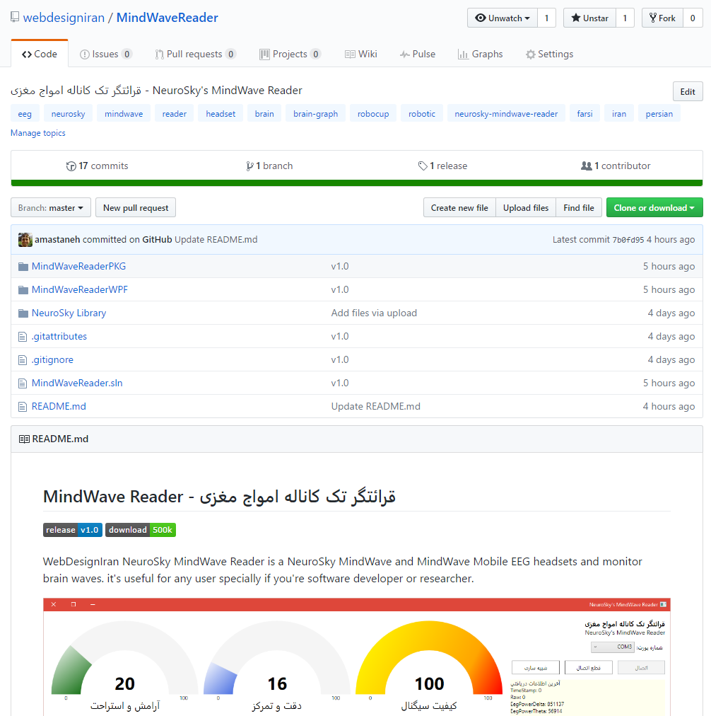

Project Address: [github.com/WebDesignIran/MindWaveReader](https://github.com/webdesigniran/MindWaveReader)

Latest Edition: [github.com/WebDesignIran/MindWaveReader/releases](https://github.com/webdesigniran/MindWaveReader/releases)

Download: [github.com/WebDesignIran/MindWaveReader/releases](https://github.com/webdesigniran/MindWaveReader/releases)

Setup Project: [github.com/WebDesignIran/MindWaveReader/releases](https://github.com/webdesigniran/MindWaveReader/releases)

Report Issues: [github.com/WebDesignIran/MindWaveReader/issues](https://github.com/webdesigniran/MindWaveReader/issues)